****Part 1 - Advanced Web Exploits****

q1. [1 point] -  When on the high-security setting of DVWA, a unique ANTI-CSRF token is created each time the password change page is accessed,  as shown in the workshop. To launch a CSRF attack in this case, we first need to steal the token. Create an HTML (name it: 'csrf.html') file that can steal the token from the DVWA CSRF page http://[hacklabvm_ip]/DVWA/vulnerabilities/csrf and change the password to 'csf2024s1'. You can use the template [here](https://myuni.adelaide.edu.au/courses/105132/files/16571677?wrap=1" \o "csrf.html" \t "https://myuni.adelaide.edu.au/courses/105132/assignments/_blank)[Download here](https://myuni.adelaide.edu.au/courses/105132/files/16571677/download?download_frd=1). Show the content of your csrf.html file.

****[HINT]****To properly craft the malicious HTML file, you will need to take note of the request sent by DVWA when the change password is triggered.

Our hacklabvm ip address is 192.168.116.7

Let’s set the security level to high.

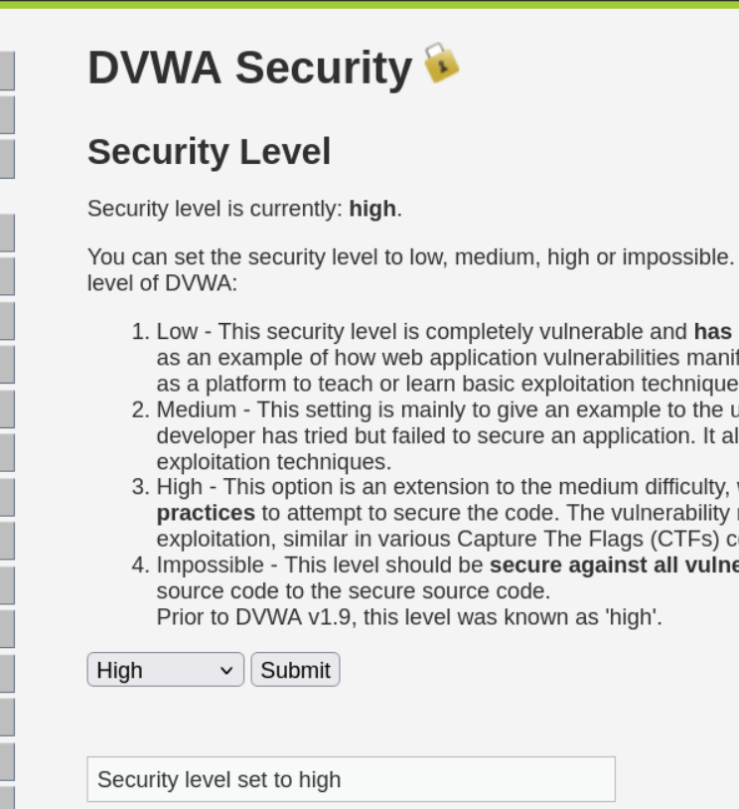

The template is located in my kali machine /var/www/html

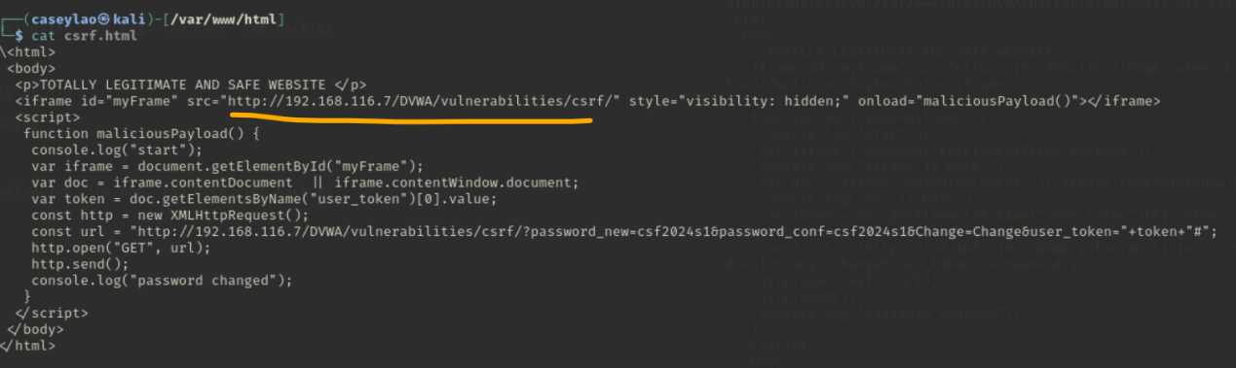

This is the template content and I fill my DVWA server ip address into src from the iframe DOM. The iframe is an inline frame which can be used to embed another document or web page. In this case, it is our DVWA/vulnerabilities/csrf page.

The reason use iframe is because when we visit the page, it will generate a user_token.

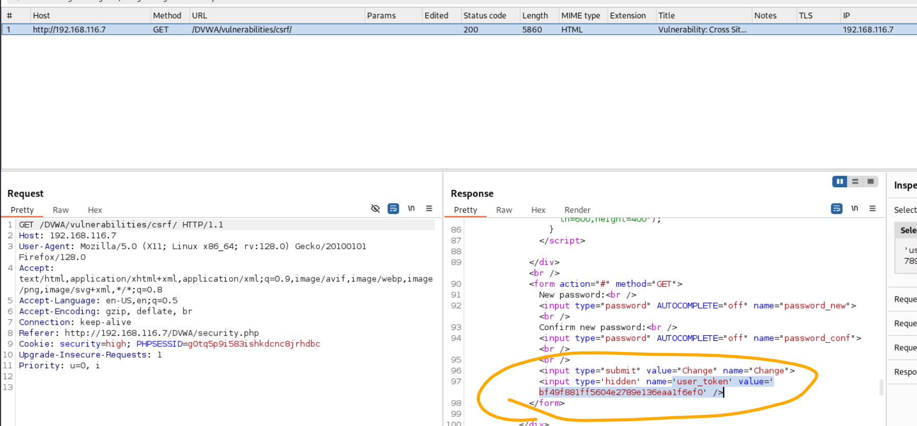

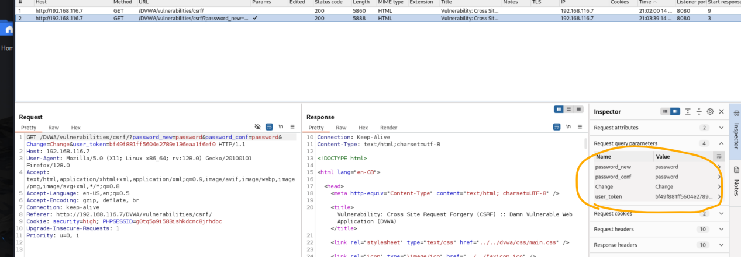

When we change the password. The url is <http://192.168.116.7/DVWA/vulnerabilities/csrf/?password_new=password&password_conf=password&Change=Change&user_token=bf49f881ff5604e2789e136eaa1f6ef0#>

Let’s use this URL to fill our template parameter const url.

The template target is visit the csrf web page. It will get the unique user_token. Then, it will send change password request. The password will be csf2024s1.

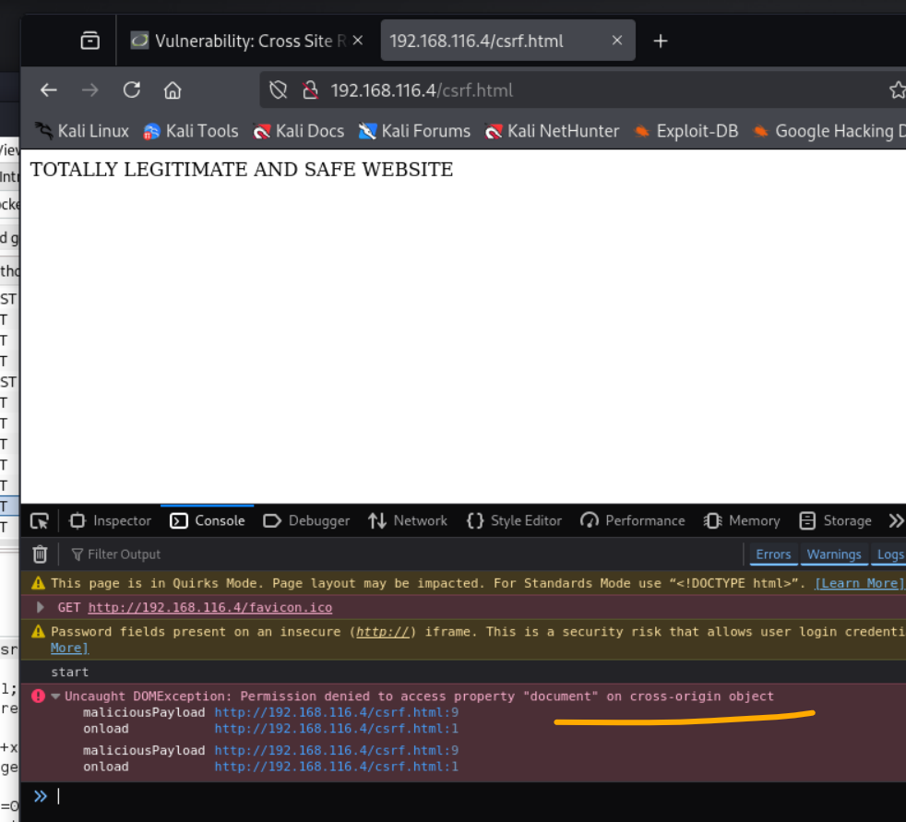

However, I can not access the document on cross-origin object. I have even close the firefox enhanced tracking protection, but it is not working. The main reason is my kali ip 192.168.116.4 is not the same origin with the DVWA Server 192.168.116.7. It has the same origin protection.

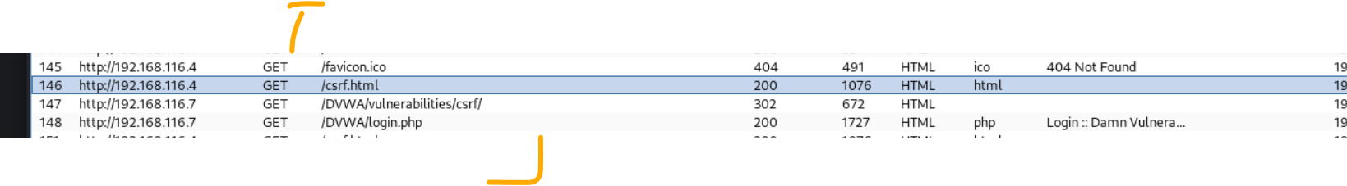

It will automatically redirect me to the login page with impossible security level. I have to find another way to change the password.

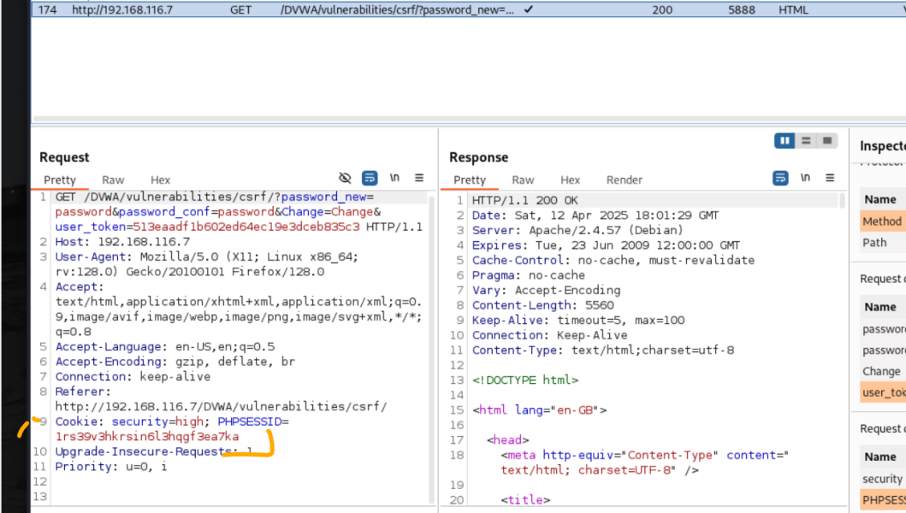

As my observation, different request has the same PHPSESSID. This is my sessionID. With it, I can directly connect to DVWA server without redirecting me to login page.

I craft a python script to help achieve the change password activity. I set my cookie with my sessionID. The package beautifulsoup can help me extract the dom content, such as user_token.

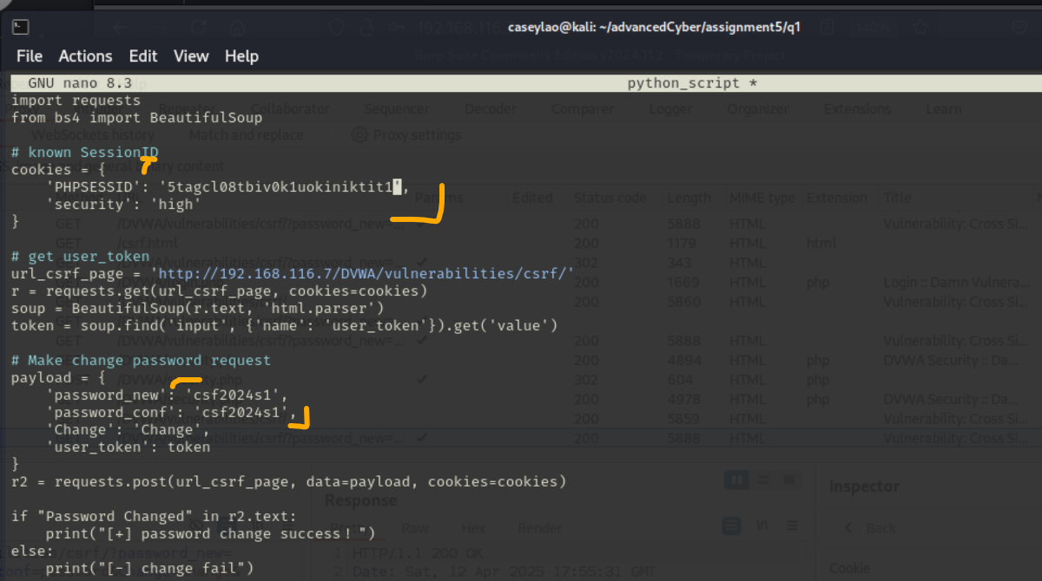

I fill my payload with new password. Csf2024s1.

After executing the python script. We test our new password. It has successfully change the password.

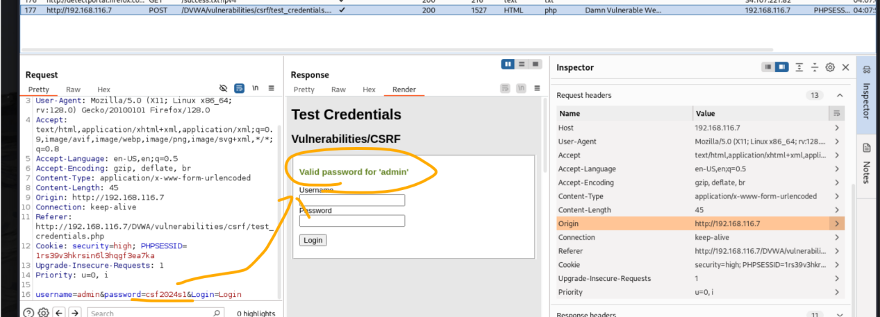

q2. [1 point] - Set the DVWA security level to MEDIUM. Upload the csrf.html file to the "hackable/uploads" folder. Provide details of the steps you use to upload the HTML file with the security level set at medium.

****[HINT]****Set the DVWA security level to MEDIUM first. At this level of security, you won't be able to upload the HTML file directly as only certain file types are allowed. You may need a proxy intervention.

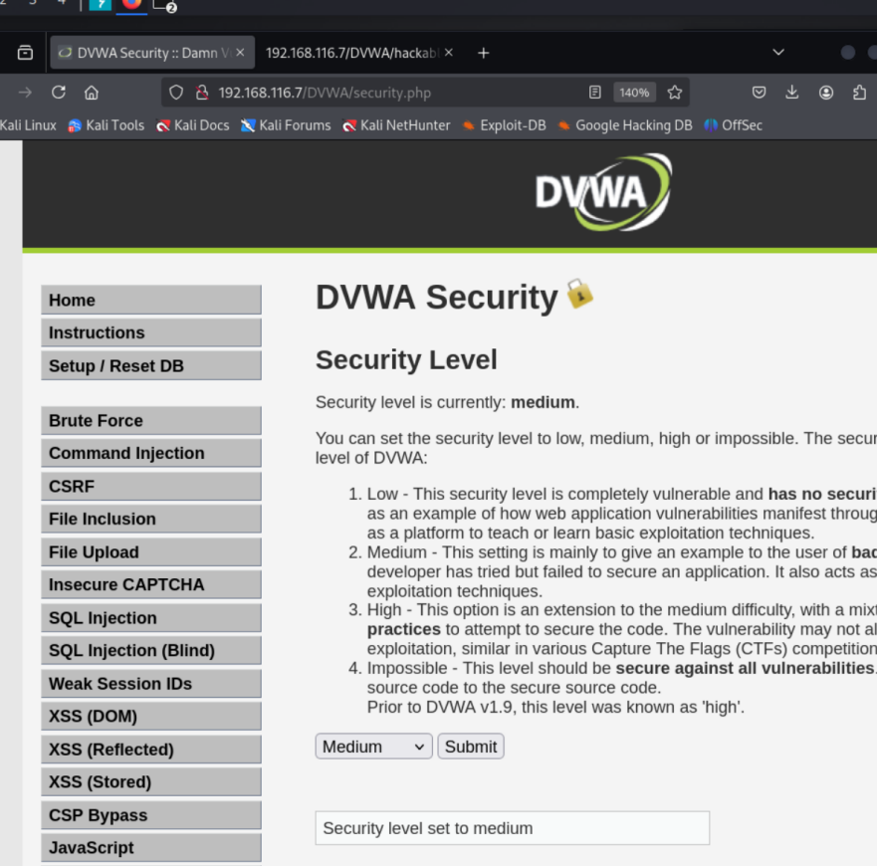

First of all, let’s set the security level to medium.

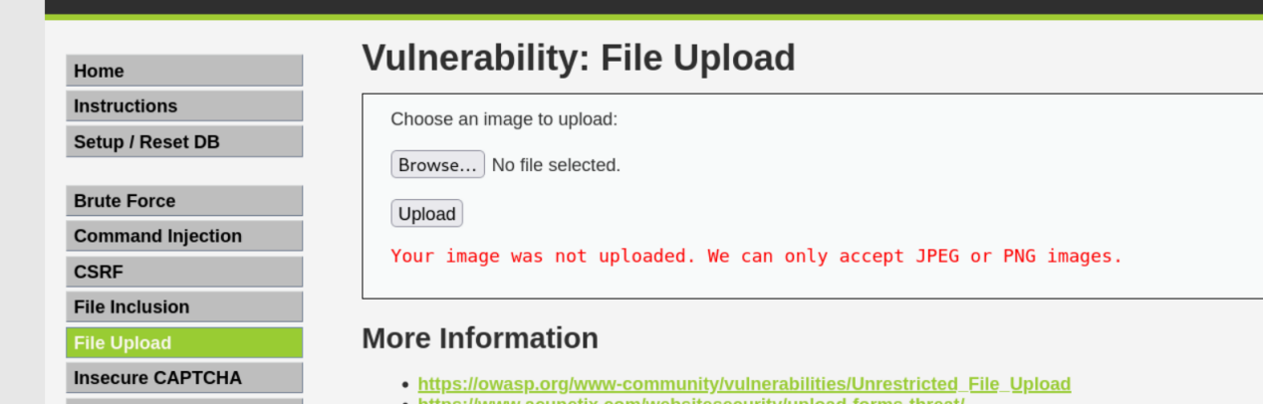

When we select the file csrf.html and click upload. It shows that we can only upload image jpeg or png file.

We check that the source file shows that it will accept a file which uploaded_type == image/jpeg or image/png.

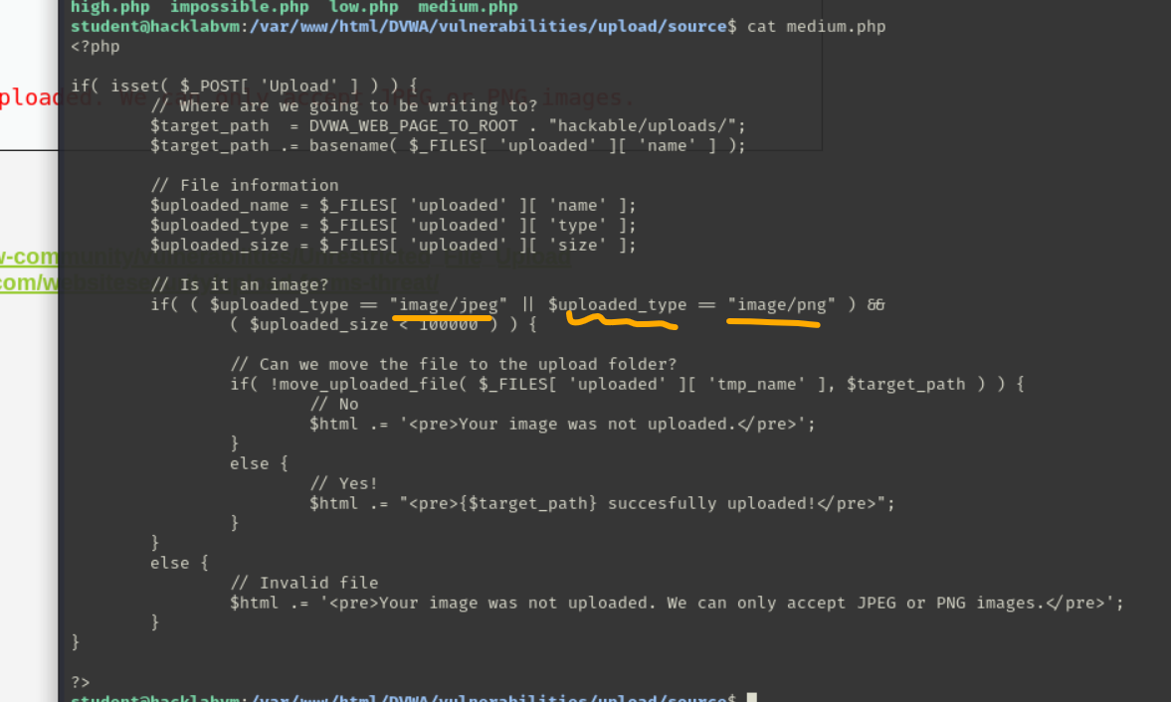

So one method is we use burpsuite to resend the request with some modifications.

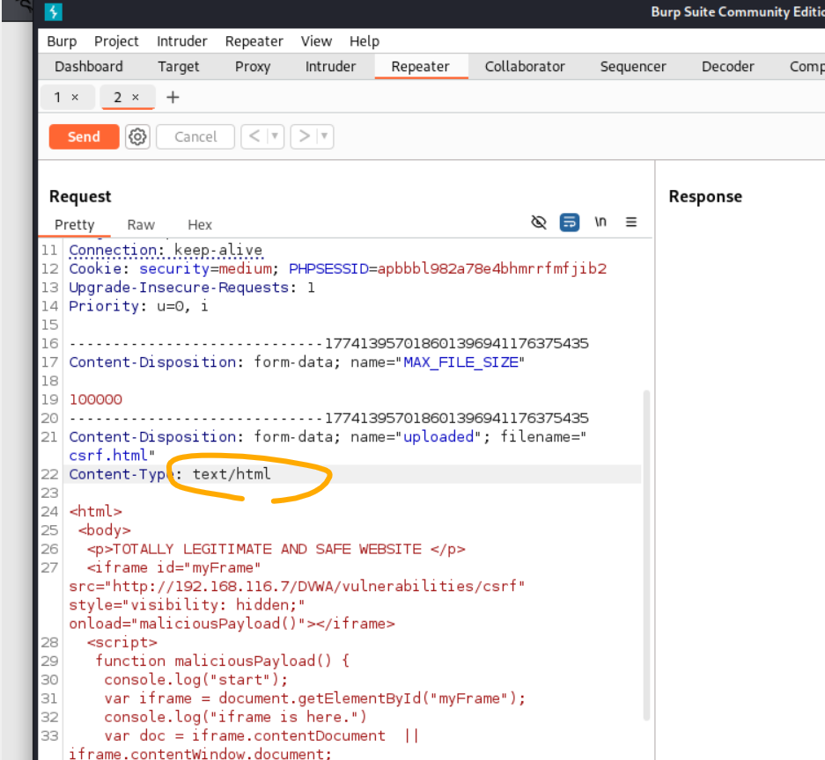

We let the upload request as a repeater, so that it can send as many time as we want. The “Content-Type” shows the csrf.html file is a text/html. Let’s modify it to image/jpeg and click send button.

The right side of the response screen shows upload successfully. The file is in DVWA/hackable/uploads folder.

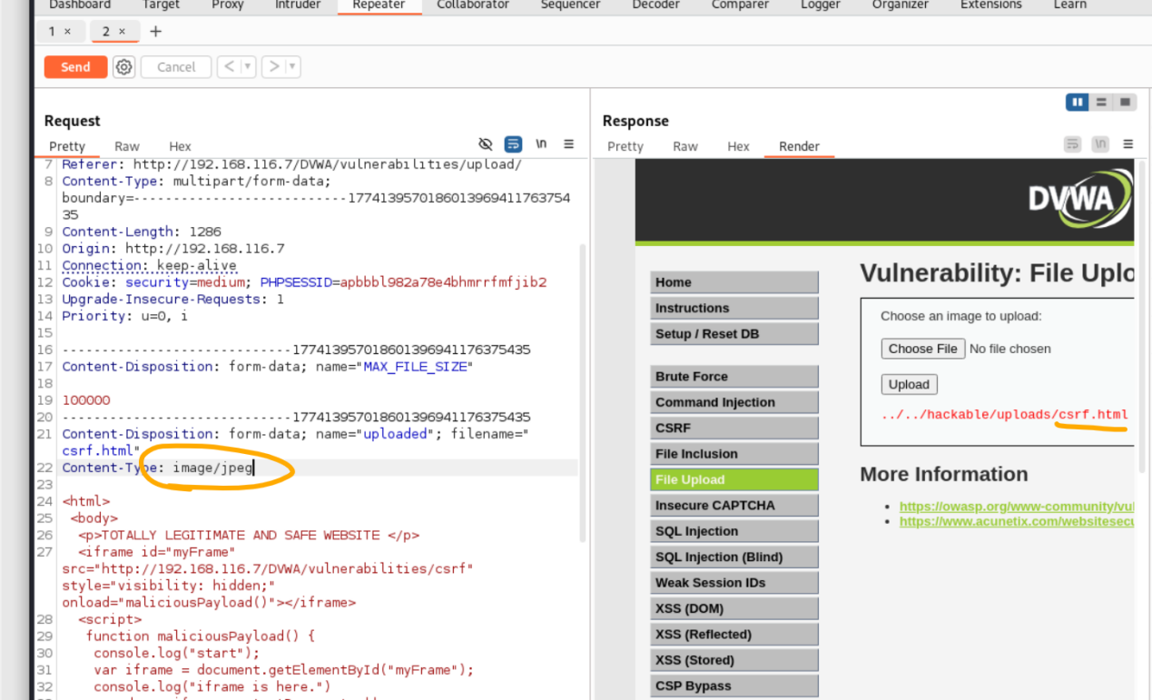

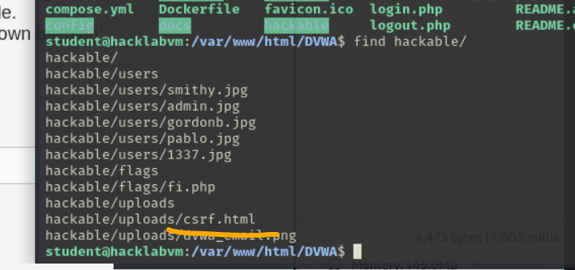

q3. [1 point] - Show that after a user visit [http://[hacklabvm_ip]hackable/uploads/csrf.htmlLinks to an external site.](http://[hacklabvm_ip]hackable/uploads/index.html1" \t "https://myuni.adelaide.edu.au/courses/105132/assignments/_blank) the password changes to 'csf2024s1'. Explain what happened.

****[HINT]****To trigger the malicious HTML, note the location where you uploaded your file. Also, consider changing the DVWA security back to high, as the anti-CSRF token is only used in high settings.

First of all, let’s check the upload folder from the DVWA server and security level.

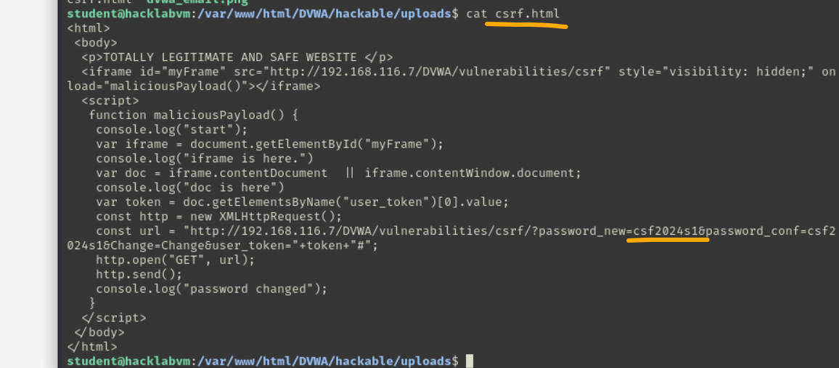

The new password is set to csf2024s1.

Once the page is visited. Iframe dom will request 192.168.116.7/DVWA/vulnerailities/csrf. This is a move to help us get the user_token. The user_token will generated when page is visited. Then, it use doc variable to have document object in order to get the user_token and append it to the const url.

The content of const url is the password changing url. It will contains the user_token at the end.

After request, the password will change to our target password csf2024s1.

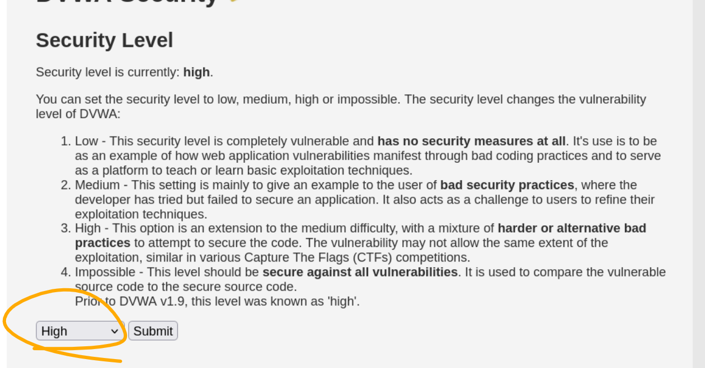

We directly visited hackable/uploads/cstf.html. The console show change successfully.

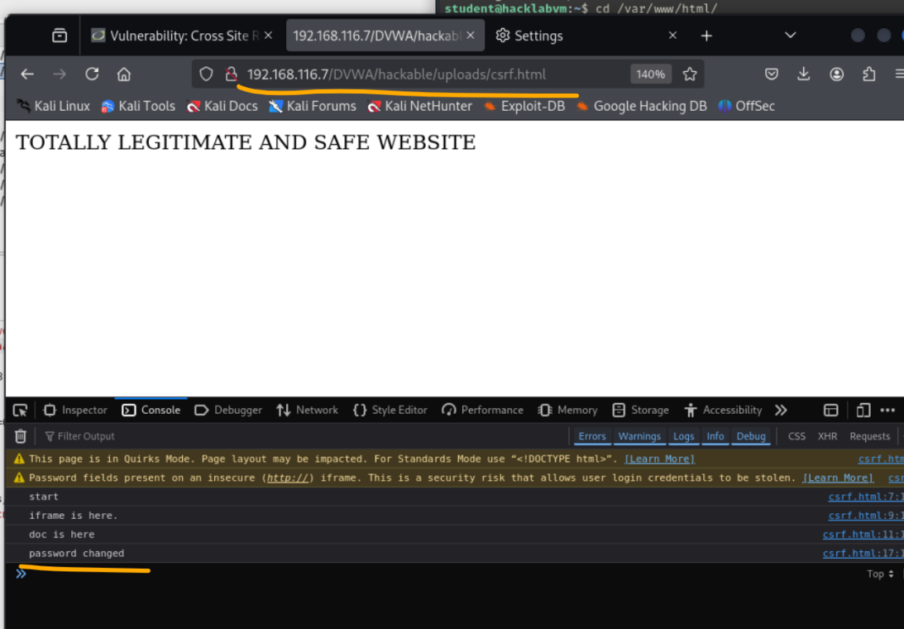

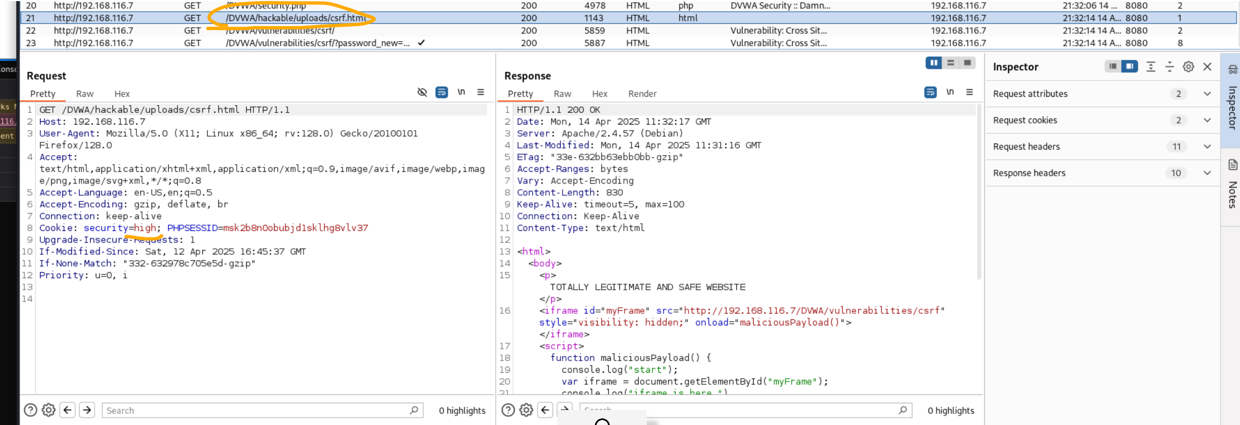

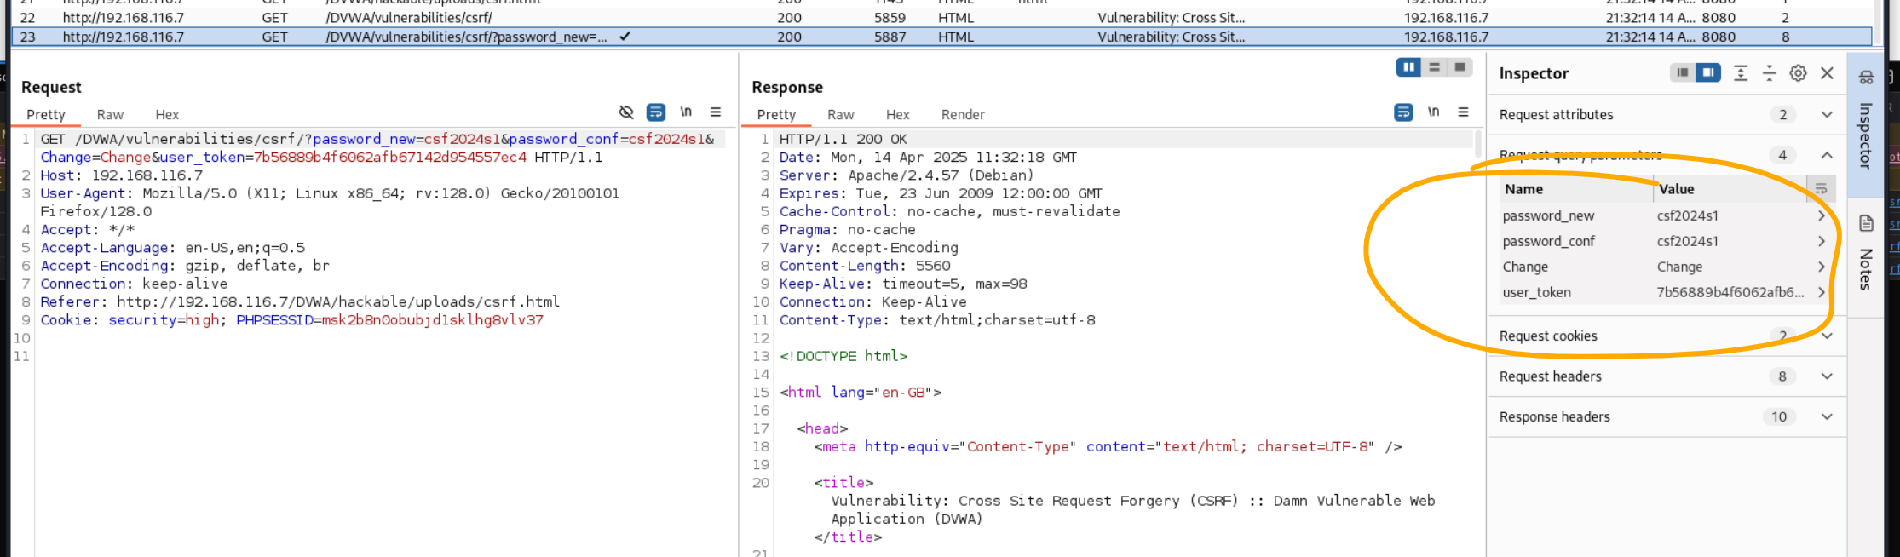

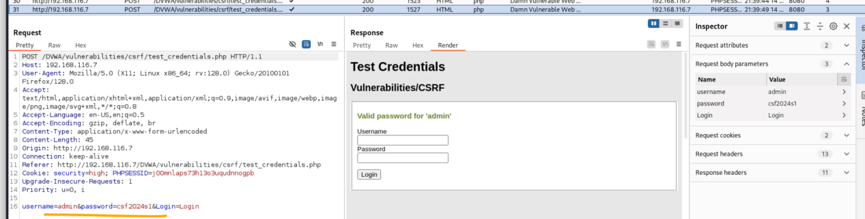

The password has changed successfully.

****Part 2 - Digital Forensics****

Marking rubric for questions 1-3  below: 0.5 point for the final flag, 0.5 point for screenshots of the proof of the process, and 1 point for an explanation of any commands/tools used and the thought process to find the answer.

q1. [2 points] Reversing (1)

* Download this [binary](https://myuni.adelaide.edu.au/courses/105132/files/16571723?wrap=1" \o "q1-2" \t "https://myuni.adelaide.edu.au/courses/105132/assignments/_blank)[Download binary](https://myuni.adelaide.edu.au/courses/105132/files/16571723/download?download_frd=1). You can run it as "./q1" in Linux
* You ARE NOT allowed to patch this program
* Use Ghidra, Cutter, or Radare2 (or something else) to decompile and deduce the password required for revealing the secret.
* Get the program to print the secret.

First of all, let’s download the file which is called “q1-2”. It is not executable, so we use chmod u+x to make it executable.

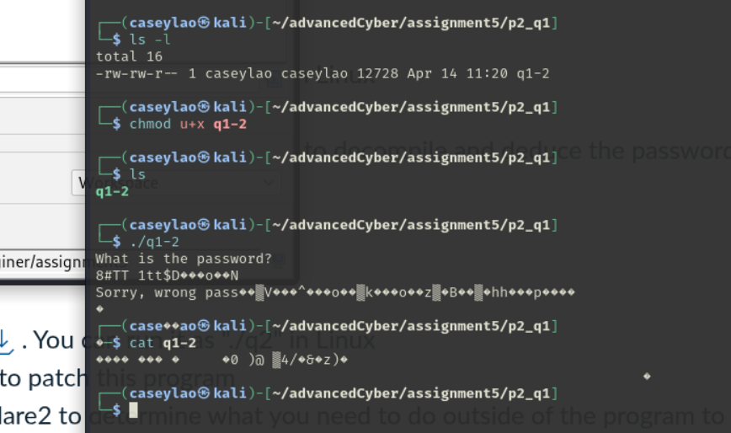

It shows that we need to input the correct password to get the flag.

We can use “Ghidra”to see the file script. We create a folder “assignment5” and drag and analyse the q1-2 file into it.

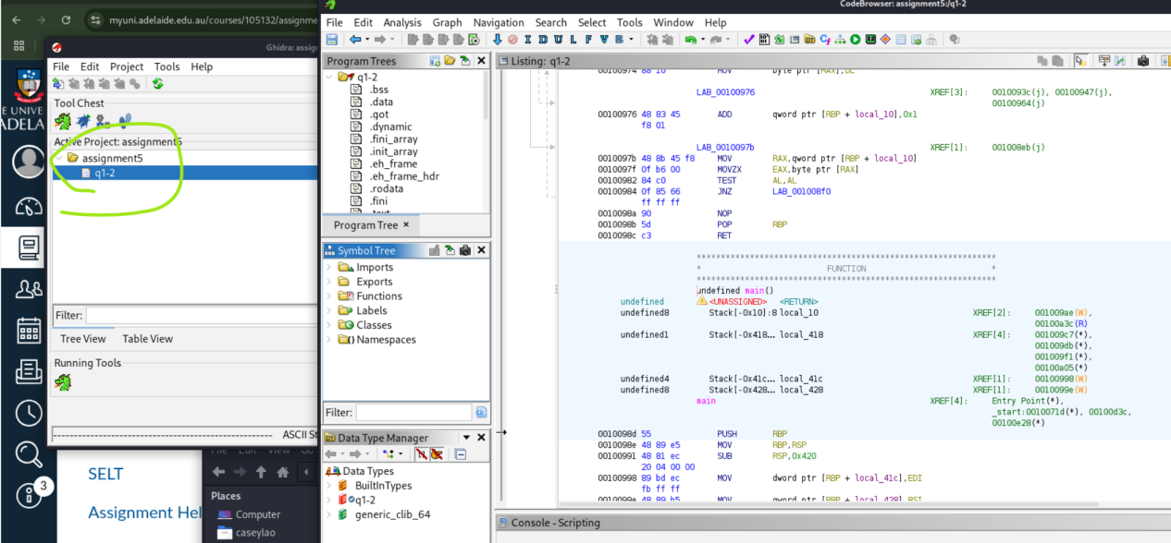

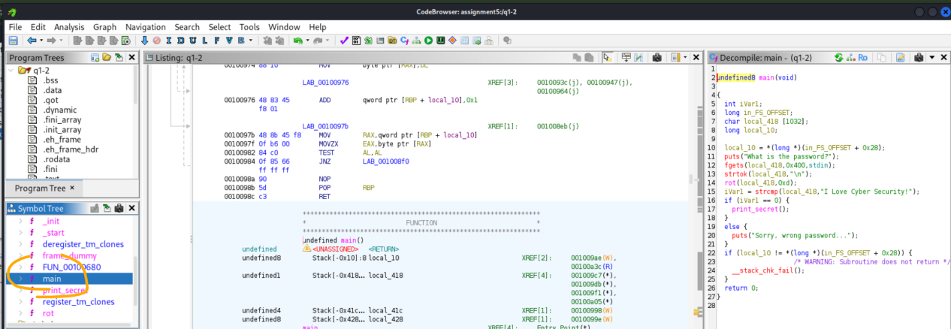

We found the main function of the script. The C code is shown on the right.

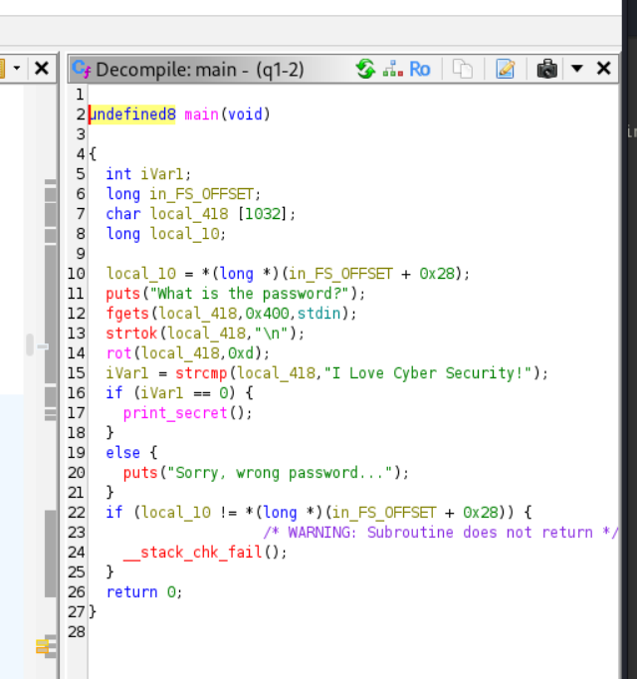

According to this code, it uses fgets function to get our input. The strtok function is used to split the input with space(“\n”). Then, we see there is a rot function which is a rotation. Let’s assume it as a encryption method ROT13. 0Xd is 13 on hexadecimal.

The strcmp will compare our input with the string “I Love Cyber Security!”. This is our password.

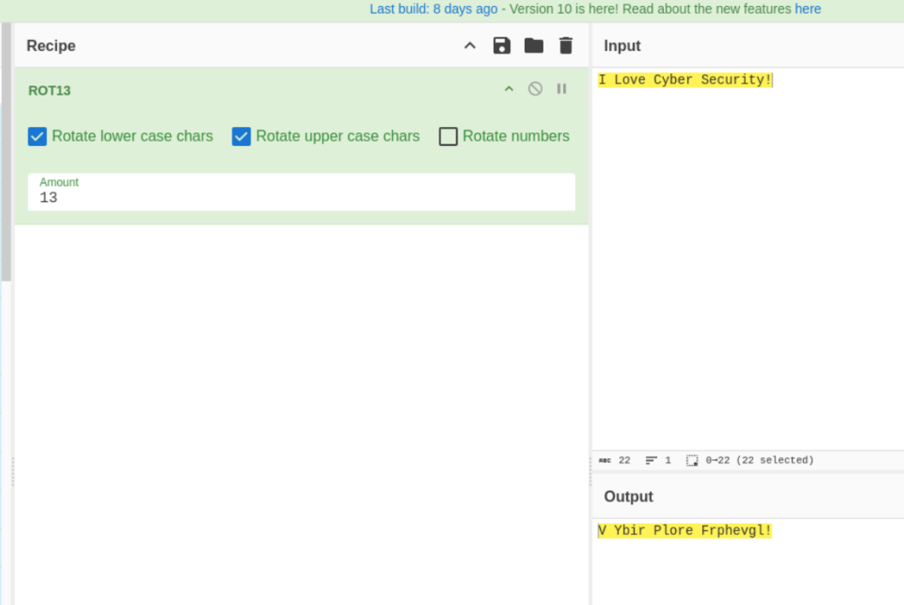

We use the tool CyberChef to see what is the result after ROT13. The result is similar to Caesar encryption. a ---> n, b--->o, c--->p.

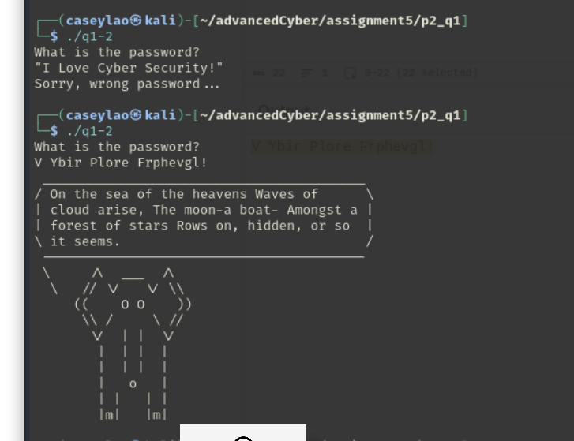

After we enter the transform password, we get the flag.

q2. [2 points] Reversing (2)

* Download this [binary](https://myuni.adelaide.edu.au/courses/105132/files/16571724?wrap=1" \o "q2-2" \t "https://myuni.adelaide.edu.au/courses/105132/assignments/_blank)[Download binary](https://myuni.adelaide.edu.au/courses/105132/files/16571724/download?download_frd=1). You can run it as "./q2" in Linux
* You ARE NOT allowed to patch this program
* Use Ghidra/Cutter/Radare2 to determine what you need to do outside of the program to get it to reveal the secret
* Get the program to print the secret

Same as the question 1. Let’s analyse the q2-2 with Ghidra application.

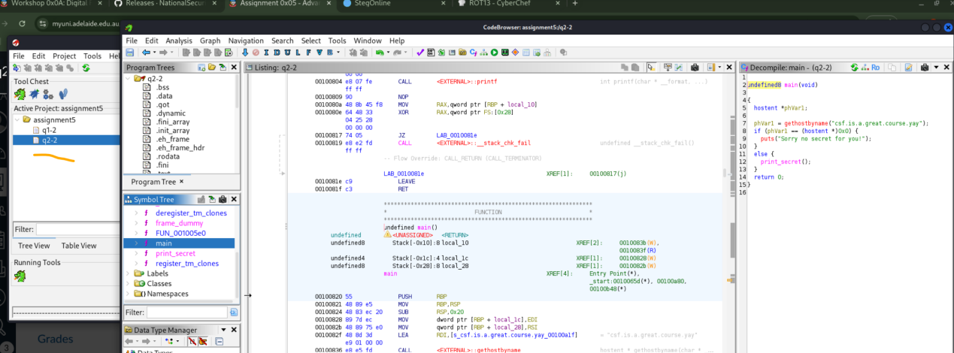

The code shows it will use the gethostbyname function to get the value and assign it to parameter phVarl.

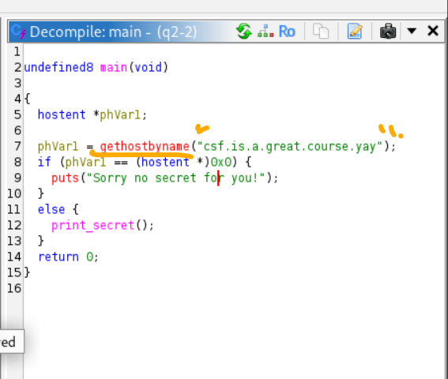

The gethostbyname will return a pointer to a hostent structure for the host name. (hostent *)0x0 means null. If the phVarl is null, then print “sorry no secret for you”, otherwise, it will show secret.

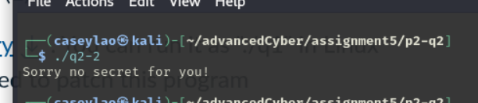

If we somehow make the host name “csf.is.a.great.course.yay” a real host name, we can get the secret.

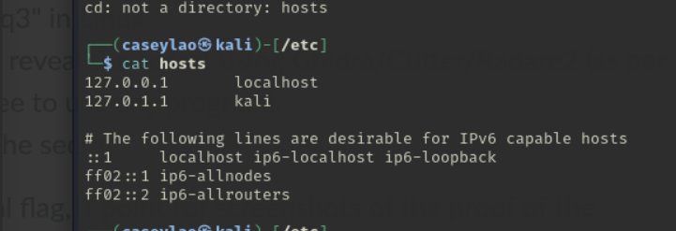

The /etc/hosts files is a plain text file used in matching with the server IP. If DNS is not available, user can still visit the ip by the file matching.

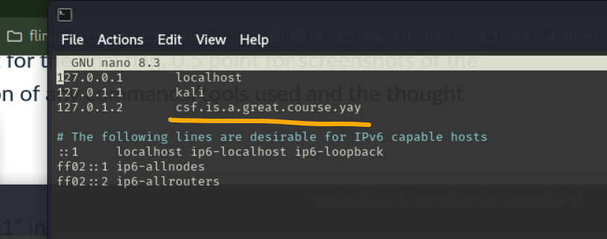

We add the host name to our /etc/hosts file.

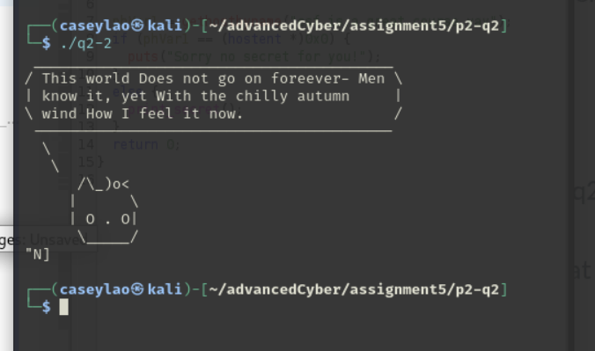

We get the flag.

q3. [2 points] Reversing (3)

* Download this [binary](https://myuni.adelaide.edu.au/courses/105132/files/16571725?wrap=1" \o "q3-2" \t "https://myuni.adelaide.edu.au/courses/105132/assignments/_blank)[Download binary](https://myuni.adelaide.edu.au/courses/105132/files/16571725/download?download_frd=1). You can run it as "./q3" in Linux
* YOU SHOULD patch this program to get it to reveal the secret using Ghidra/Cutter/Radare2 (as per workshop, I think Cutter is easiest, but feel free to use any program).
* Use the modified (patched) program to print the secret

Marking rubric for question 4: 1 point for the final flag, 1 point for screenshots of the proof of the process, and 1 point for an explanation of any commands/tools used and the thought process to find the answer.

Same as the question above, let’s use Ghidra to analyse the file.

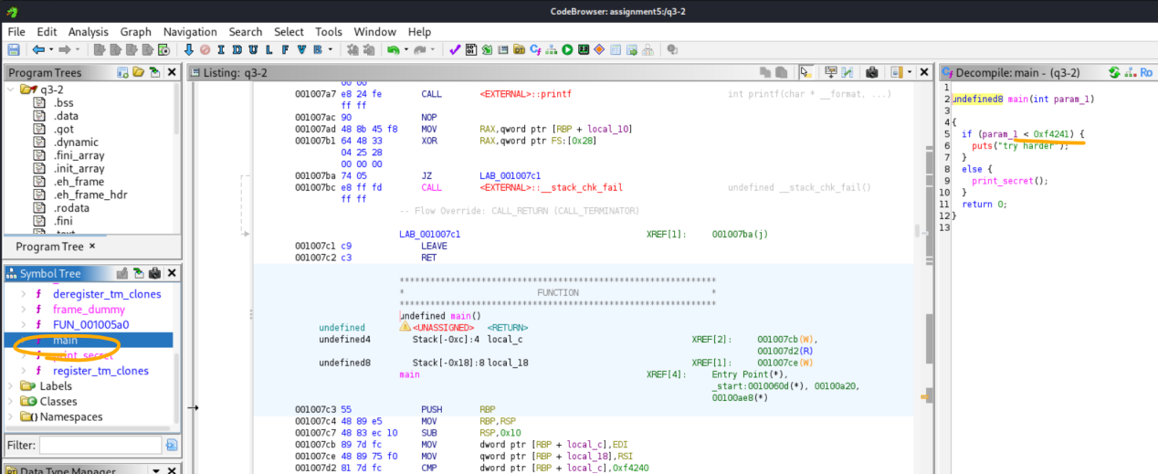

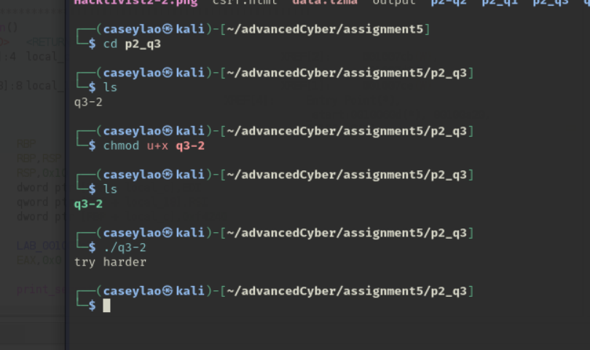

Use chmod command to make the file executable.

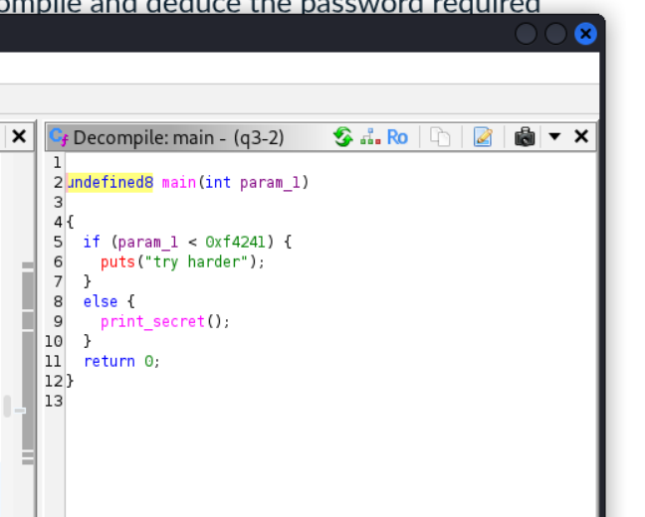

According to the code, if the param_1 is larger than 0xf4241 (1000001 in decimal number), it will print_secret().

In c program, param_1 means the number of parameters input. Let’s try input 1000001 parameters into the code.

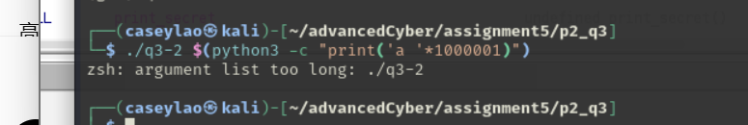

It seems we enter to many values into the code. The linux kernel is not allow great amount of parameters. The other way is we use gdb tool. The gdb tool can help us access the memory level of the program, so we can manually set the param_1 to 1000001 and run the program.

According to the ghidra tool analysis result, the program has the main function. We can break it.

The file is a x86_64bit file.

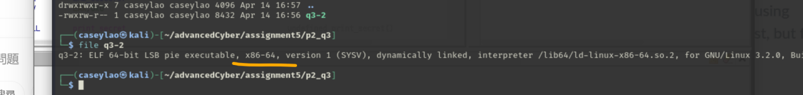

In gdb, we break main function and run the program. Since we can not see the memory, we can assume that the register $rdi is point to the first parameter, according to the rule of x86_64, which is param_1. We set it to 1000001, and continue to see what happen.

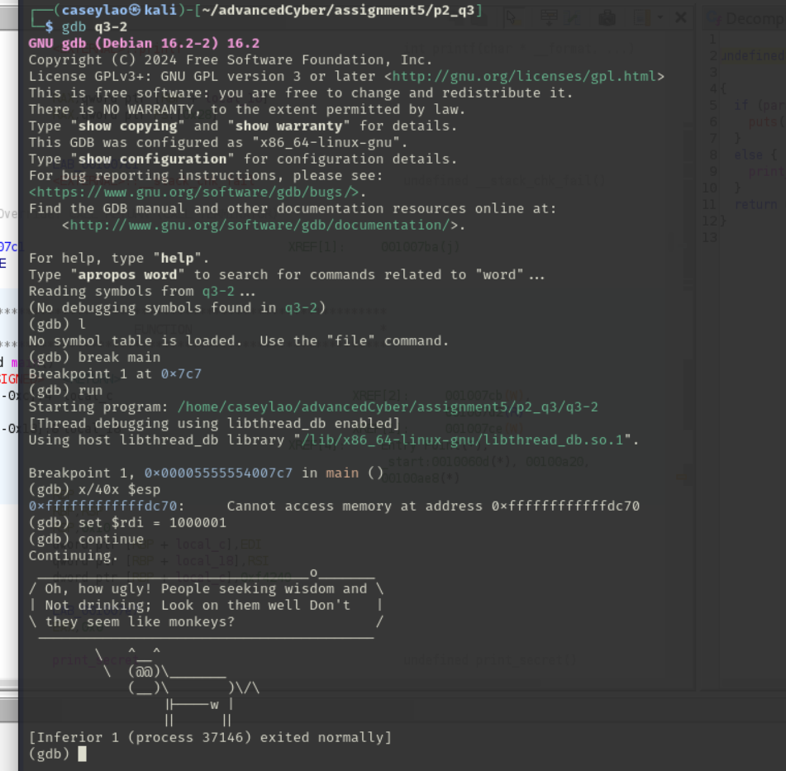

We get the flag.

q4. [3 points] Matryoshka

* Analyse this [Hacktivist2-2.png](https://myuni.adelaide.edu.au/courses/105132/files/16571726" \o "Link" \t "https://myuni.adelaide.edu.au/courses/105132/assignments/_blank) downloadto get the secret!

First of all, let’s download the image. It seems nothing special.

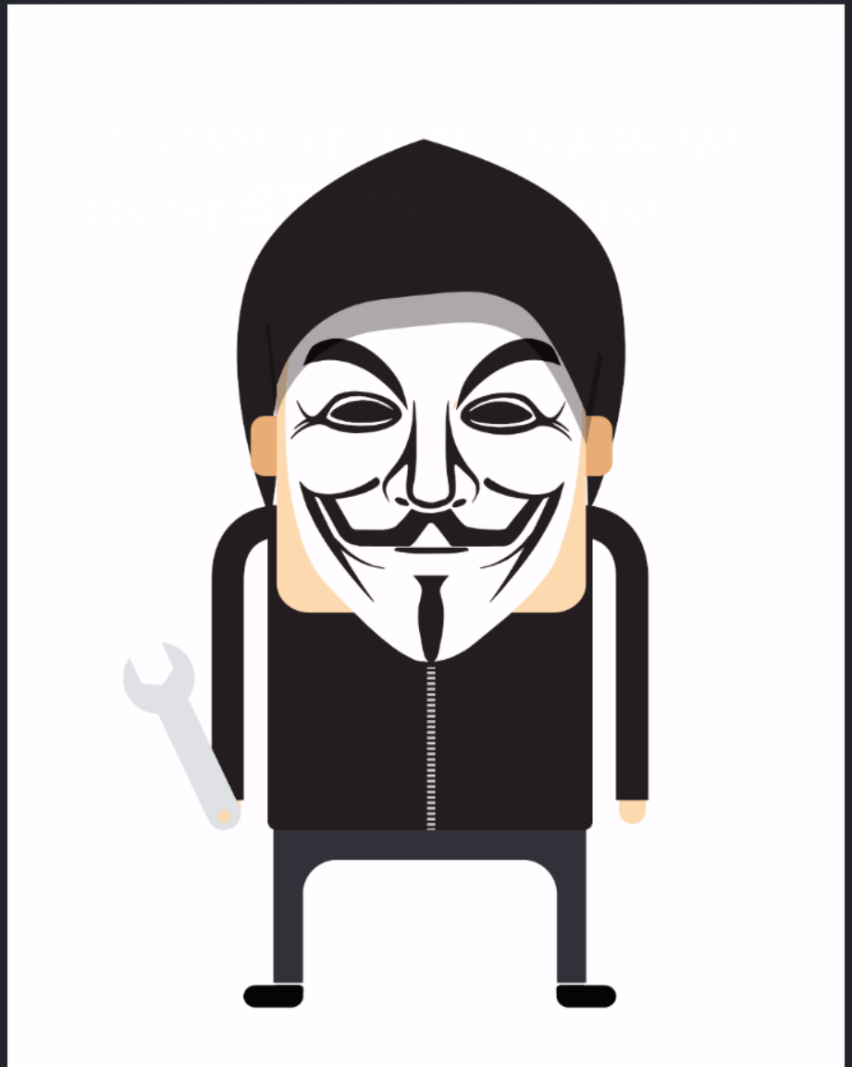

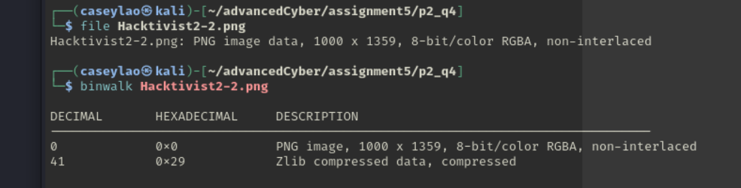

The picture has a compressed data within it. We can use stegOnline tool to see different bitplane of the picture.

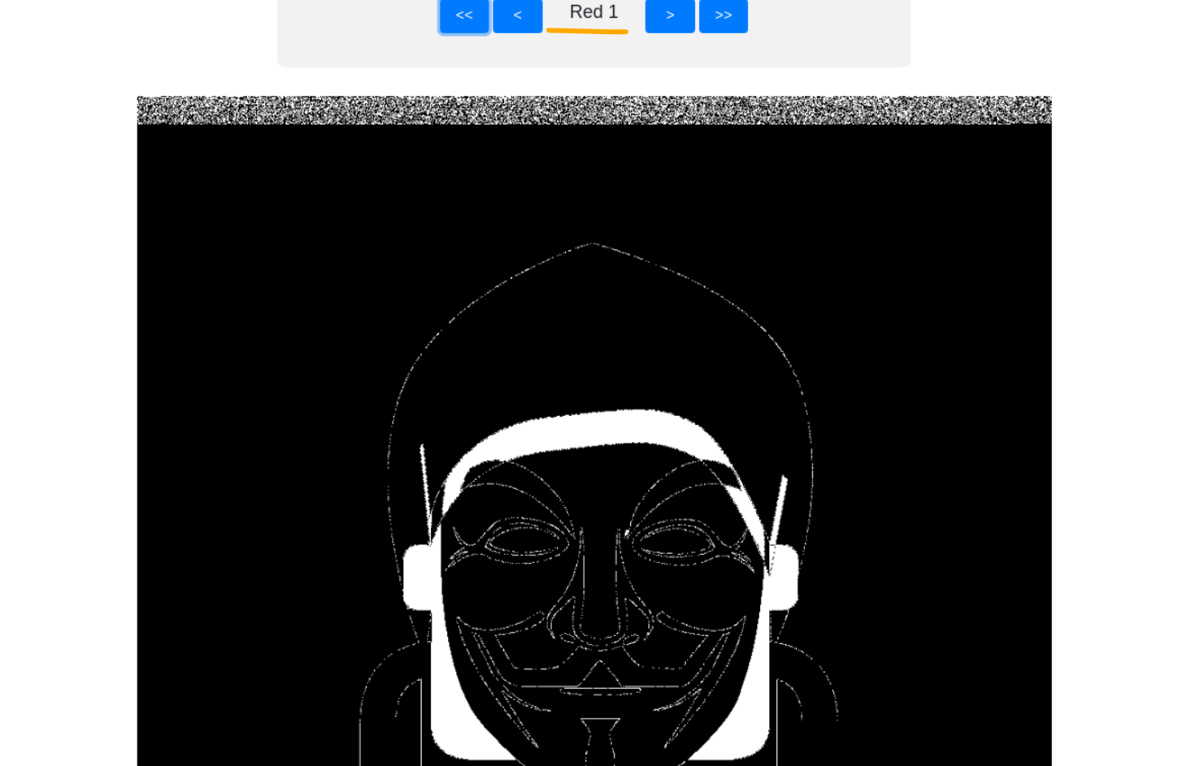

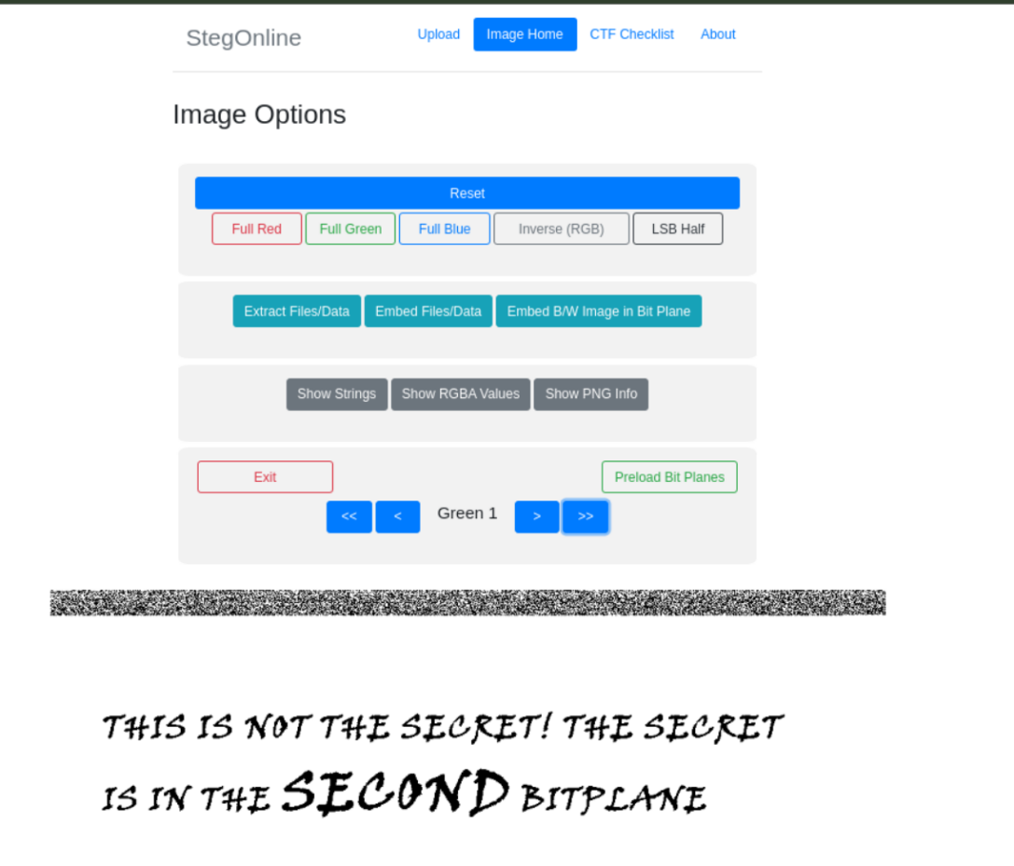

We can see the bitplane has a totally different message. The message said “This is not the secret! The secret is in the second bitplane.” However, we are already in the second bitplane. After look through every bitplane, there is nothing interesting.

In this situation, maybe there has another message within the second bitplane. Let’s extract it out.

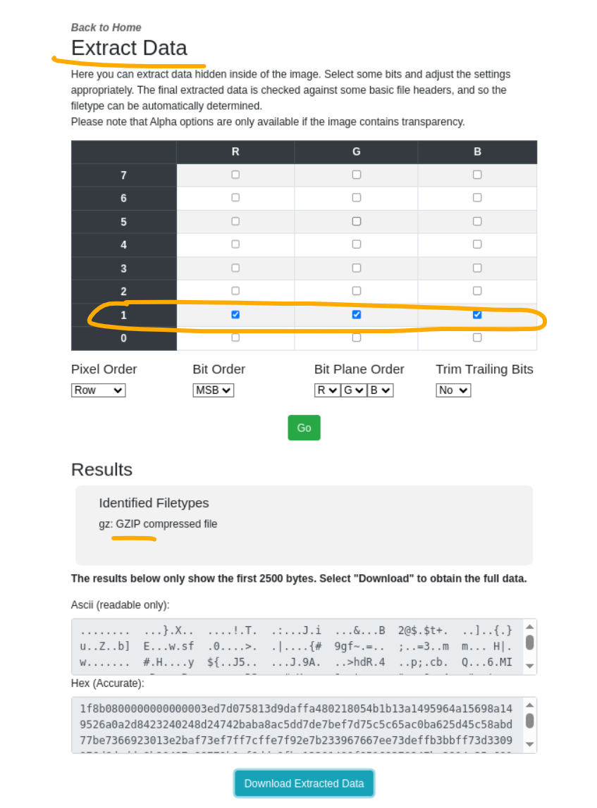

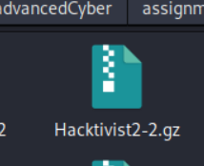

It is .gz file.

We use command **gunzip -k Hacktivist2-2.gz** to unzip the file, and we get the file called hacktivists2-2.

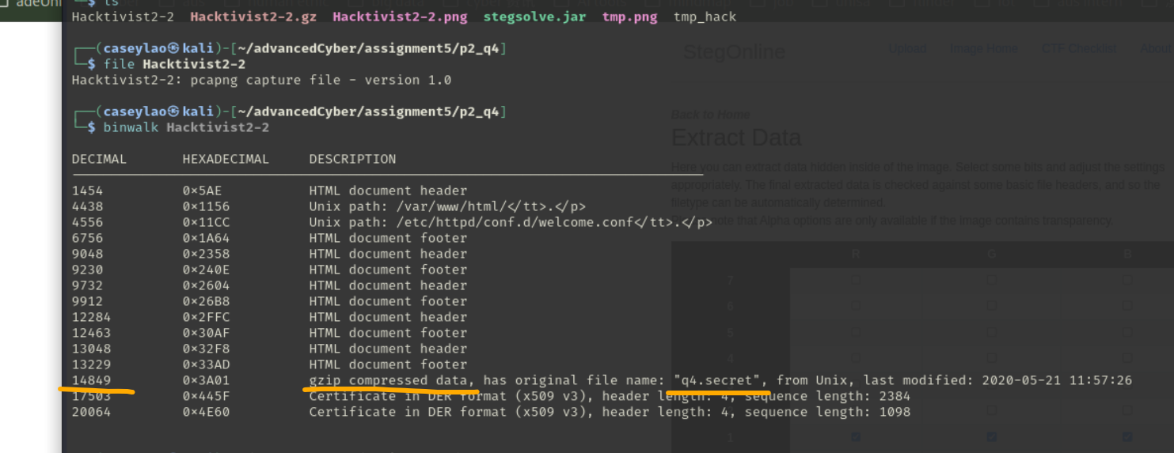

Hacktivist2-2 is a pcapng capture file. There is also a gzip compressed data in 14849. Most importantly, the description shows it is a q4.secret.

We use dd command to extract the file called tmp_hack.gz. Use gunzip to unzip the file. It is a ASCII text.

Finally, we can see the flag.

